**X-ray Tube Heat Dissipation Modelling**

## 

## **Submitted By:**

## Team #14

## 

## **Team members:**

Shehab Mohamed

Mohamed Aziz

Mahmoud Emad

Mohamed Hazem

Omar Mohamed Mahmoud

**2024-2025**

# Report on X-Ray Tube Thermal Modelling

## 1. Overview

The purpose of this report is to analyse the thermal modelling of an X-ray tube, focusing on heat generation and dissipation mechanisms. The model incorporates theoretical principles, scientific constants, and numerical simulations to predict the thermal behaviour of an X-ray tube during operation.

X-ray tube generate X-rays by directing high-energy electrons toward a metal target, which in turn produces X-ray radiation through interactions with atomic nuclei. However, a significant portion of the electron energy is converted into heat rather than X-ray radiation. Effective heat dissipation is crucial to ensure the longevity and optimal performance of X-ray tubes. This essay explores the principles of heat generation in X-ray tubes, the various heat dissipation methods employed, and the mathematical modeling techniques used to optimize thermal management.

## 2. Heat Generation in X-Ray Tubes

In an X-ray tube, high-speed electrons emitted from a heated cathode are accelerated towards a metal anode due to a high potential difference. Upon collision, approximately 99% of the electrons' kinetic energy is converted into heat, while only about 1% is converted into X-rays. This significant heat load can lead to thermal damage, reducing the tube's efficiency and lifespan.

The main sources of heat generation include:

1. **Joule Heating:** Resistance heating of the filament due to electric current.
2. **Impact Heating:** Energy deposition when electrons strike the anode.
3. **Secondary Radiation Heating:** Absorption of secondary X-ray photons and electrons within the tube components.

## 3. Heat Generation in X-Ray Tubes

Given the immense heat generation, efficient cooling mechanisms are required. The primary heat dissipation methods in X-ray tubes include:

1. **Radiation Cooling:** The anode radiates thermal energy in the form of infrared radiation.
2. **Conduction Cooling:** Heat is transferred through direct contact between components, often from the anode to a heat sink.
3. **Convection Cooling:** Air or liquid cooling systems, such as oil circulation, remove heat from the anode and surrounding components.
4. **Rotating Anode Design:** A rotating anode spreads the heat over a larger surface area, reducing localized thermal stress.

## 4. Key Components of the Thermal Model

### 4.1 Physical Constants Used

- Stefan-Boltzmann Constant (σ): 5.67×10⁻⁸ W/m²K⁴  
- Ambient Temperature: 22°C  
- Kelvin Offset: 273.15 (used to convert °C to K)

### 4.2 Material Properties

The model includes a lookup table for thermal properties of different materials such as tungsten, molybdenum, and copper, including:  
- Thermal Conductivity (W/mK)  
- Specific Heat Capacity (J/kgK)

### 4.3 Heat Transfer Mechanisms

The model accounts for the following heat transfer mechanisms:

* **Radiative Cooling**: Governed by the Stefan-Boltzmann Law:  
   Q = σ ⋅ A ⋅ ε ⋅ (T2^4 – T1 ^4)
* **Convection**: Modeled using Newton’s Law of Cooling:  
   Q = h ⋅ A ⋅ (T2 – T1)
* **Conduction**: Used to simulate heat transfer between different components of the X-ray tube.

Q = k ⋅ A ⋅ (T2 – T1) / L

Where**:**

**Q** is the heat transfer rate,

**A** is the surface area,

**T** represents temperature variables,

**h** is the convection coefficient,

**ε** is emissivity,

**σ** is the Stefan-Boltzmann constant,

***k*** is thermal conductivity,

and **L** is effective path length.

## 5. Simulation & Visualization

The model simulates temperature changes over time using numerical methods to integrate the heat transfer equations. Matplotlib is used for visualization, plotting temperature evolution curves and heat dissipation over time.

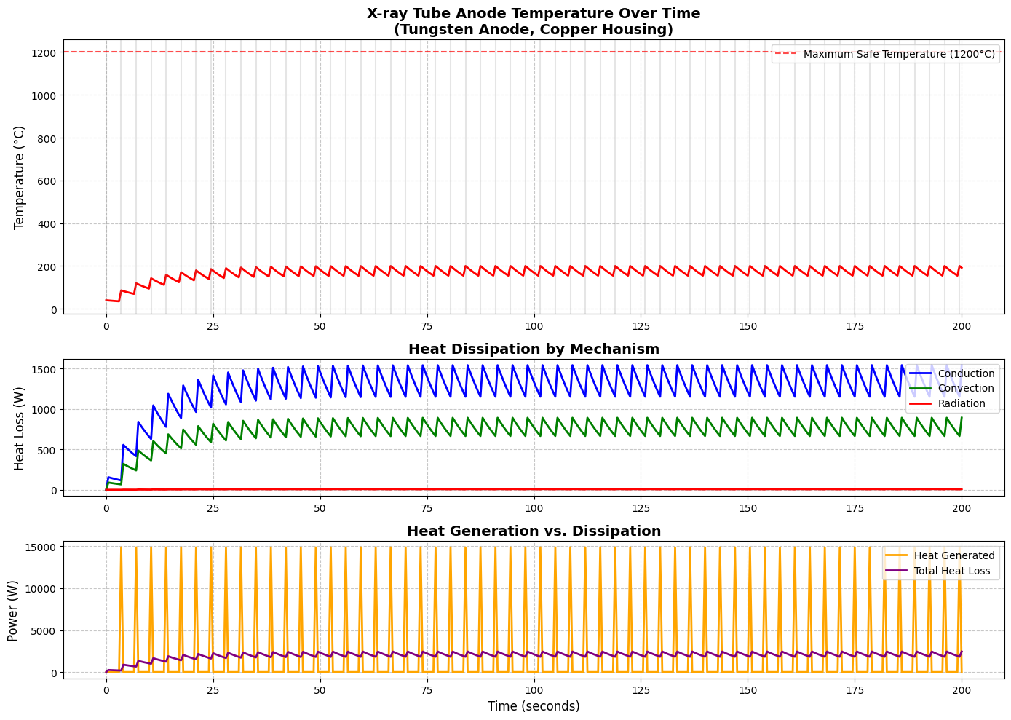

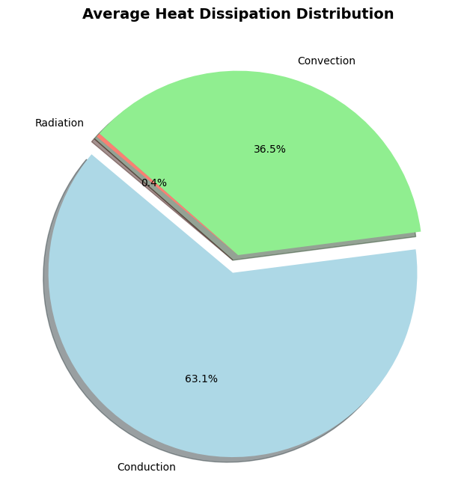

## 6. Conclusion

The implemented thermal model provides an effective way to analyze heat generation and dissipation in X-ray tubes. Future improvements could include additional materials, real-time user interaction, and enhanced numerical solvers for increased accuracy.

## References

1. 'Thermal loads of X-ray tubes with a fixed anode under long-duration exposure' - Discusses temperature dynamics in multilayer fixed anodes. [Springer](https://rd.springer.com/article/10.1007/s10740-006-0093-0)

2. 'Enhancing heat transfer in X-ray tubes by van der Waals heterostructures-based thermionic emission' - Explores novel heat transfer methods. [arXiv](https://arxiv.org/abs/2410.02153)

3. 'A practical method to determine the heating and cooling curves of X-ray tube assemblies' - Provides a calorimetric approach to measure heating and cooling curves. [PubMed](https://pubmed.ncbi.nlm.nih.gov/17985643/)

4. 'Thermal Analysis of the Focal Spot of Anodes of Powerful X-Ray Tubes' - Covers calculations of temperature fields in rotating anodes. [RCSI Journals](https://journals.rcsi.science/0006-3398/article/view/235245/en_US)